The National Data Opt-Out

Guidance for Practices

V1.3 January 2023

Contents

1. Background 3

2. What has changed 3

3. How can patients Opt Out and what does it mean? 4

4. Exemptions to Opt Out 5

5. What an organisation should do 6

6. Practices need to comply with 6

7. Further help and Support 6

8. Points to note – GP Practice 7

9. Useful resources 9

10. Document Control 10

# Background

Health and care organisation hold huge amounts of patient Information. This information is essential for enabling high quality care and is beneficial for many other purposes.

Patients have the right to opt-out of their personal confidential data being used for purposes beyond their direct care. All health and care organisations must respect this right.

Direct care is defined by the National Data Guardian review as:

*“A clinical, social, or public health activity concerned with the prevention, investigation and treatment of illness and the alleviation of suffering of individuals. It includes supporting individuals’ ability to function and improve their participation in life and society. It includes the assurance of safe and high-quality care and treatment through local audit, the management of untoward or adverse incidents, person satisfaction including measurement of outcomes undertaken by one or more registered and regulated health or social care professionals and their team with whom the individual has a legitimate relationship for their care.”*

# What has changed

**Type 2 Opt-Out**

Before 25th May 2018, GP practices would record a patient’s preferences to opt out of having their personal confidential data being used for research or planning via a Type 2 Opt-Out. As of October 2018, all patients who had a Type 2 Opt-Out applied to their GP record had their preference transferred to the National Data Opt-Out. The list of patients with a Type 2 Opt-Out was transferred from the GP practices control to a database which is held by NHS Digital. Practices no longer hold a list of these patients.

As the Type 2 Opt-Out is no longer relevant, practices should ensure that they have removed any details of how patients can request them from their website or surgery communication. They should instead signpost patients to the NHS App, the ‘[Your Data Matters](https://www.nhs.uk/your-nhs-data-matters/)’ site or the telephone number where they can register a National Data Opt-Out.

The National Data Opt-Out will still allow patients’ personal confidential and special category data to be gathered from their GP surgery by NHS Digital but will be excluded from planning or research activities.

Practices wishing to share a patient’s personal confidential or special category data for any planning or research should assess if there is a legal basis which allows confidentiality to be overridden or run the list of patients details through the MESH. Users of TPP or EMIS should already have a technical solution on their system. This will remove those patients who have a NDOO applied to their record.

# How can patients opt out and what does it mean?

Patients have the right to opt out of having their personal confidential data being used for purposes other than their individual direct health care. This means that before the practice can share, disclose, or allow access to personal identifiable data by other organisations for purposes other than to provide them with individual direct health care (such as planning or research), patients should be offered the right to object via an opt-out.

There are exemptions to opting out and cases where sharing patients’ personal confidential data outside of their direct care is allowed. For more details, see below in section 4.

**Type 1 Opt-Out**

Patients may opt out of having their personal confidential data being extracted or shared by the GP practice for purposes other than their individual direct care.

It is the responsibility of the GP practice to record **Type 1 Opt-Outs** on the patient’s record. Type 1 Opt-Outs only apply to GP data.

Patients can request that a Type 1 Opt-Out is applied to their medical record using the codes provided. This means that before the GP practice wish to share patients’ details for anything other than the patients individual direct care, they have to exclude those patients from their search criteria.

It also means that when NHS Digital extract patient data from GP practices in order to inform planning or research those patients will be excluded from the extraction. It does not apply to the data NHS Digital collects from other health providers.

**The National Data Opt-Out – NDOO**

The National Data Opt-Out replaced the Type 2 Opt-Out Programme in May 2018. All patients who do not wish to have their personal confidential data used for planning or research will be excluded from these uses. Patients with an NDOO applied will still have their data extracted from the GP practice, but it will not be used for planning or research purposes.

NHS Digital collect personal confidential data from GP practices and secondary care providers to instruct planning and research. All data collected is pseudonymised before sharing with ICBs or other organisations

# Exemptions to Opt-Out

There are exemptions to patients opting out of having their personal confidential data used for planning, research or other secondary uses as follows:

* It **does not apply** where information is being used or shared for an individual patient's care;
* It **does not apply** to information that is anonymised in line with the Information Commissioner’s Office (ICO) Code of Practice (CoP) on Anonymisation or is aggregate or count type data
* It **does not apply** when there is a legal requirement to disclose information that sets aside the common law duty of confidentiality, for example Section 251, but you will still need to determine how the common law duty of confidentiality is being met. Likewise, it **does not apply** for information required by law or a court order;
* It **does not apply** to mandatory data collections with CAG approval;
* It **does not apply** if a patient has agreed to a specific use of data. I.e., patients who have registered a national data opt-out can still agree to take part in a specific research project or clinical trial by giving their explicit consent;
* It **does not apply** if disclosure is being used to protect public health, for example to:
  + diagnose communicable diseases
  + control or prevent their spread
  + deliver and monitor vaccination programmes
  + manage risks of infection from food or water supplies or the environment
* It **does not apply** where there is an overriding public interest such as reporting of patients’ fitness to drive
* It **does not apply** to the National Cancer Patient Experience Survey (CPES) and CQC NHS Patient Survey Programme;
* It **does not apply** to local audits;
* It **does not apply** to data used to support payment and invoice validation;
* There are a small number of exceptional circumstances where clinicians, Caldicott Guardians and managers can decide to share information based on public interest, but these are made on a case-by-case basis and carefully consider the circumstances involved.
* Specific exemptions have been made for disclosure of data for:
  + Public Health England National Disease Registers
  + Assuring Transformation, i.e. It does not apply to confidential patient information about people with learning disabilities and/or autism who are in hospital for their mental health or due to challenging behaviour which is disclosed under the following approval: Assuring Transformation: Enhanced Quality Assurance Process Data flow (CAG 8-02 (a-c)/2014). These flows continue to operate a separate opt-out mechanism and details of how to opt-out of the Assuring Transformation data collection can be found [on the NHS England webpages](https://www.england.nhs.uk/learning-disabilities/care/atd/). This exemption is time limited until the end of the “Building the Right Support Programme”.
  + National patient experience surveys
* There are specific rules in the application of national data opt-outs to data flows into and out of NHS Digital as these recognise NHS Digital’s role as the national safe haven and the specific powers it has under the Health and Social Care Act 2012. Further information about these can be found in the [Policy Guidance Document](https://digital.nhs.uk/services/national-data-opt-out/operational-policy-guidance-document).

# What an organisation should do

* Review the compliance checklist in point 7
* Plan and document procedures to apply national data opt-outs
* Make sure staff, patients, and those you share data with are aware that any data being used for purposes beyond direct care may be subject to the data opt-out
* Ensure that patients understand when they can apply an opt-out
* Implement a technical solution to access the Check for National Data Opt-Outs service
* Where necessary, install [Messaging Exchange for Social Care and Health (MESH)](https://digital.nhs.uk/services/national-data-opt-out/compliance-with-the-national-data-opt-out/check-for-national-data-opt-outs-service)

# Practices need to comply with

* [NHS Digital Code of Practice on Confidential Information](https://digital.nhs.uk/data-and-information/looking-after-information/data-security-and-information-governance/codes-of-practice-for-handling-information-in-health-and-care/code-of-practice-on-confidential-information) – this defines the steps that organisations must, should and may take to ensure that confidential information is handled appropriately;
* [Information Standard](https://digital.nhs.uk/data-and-information/information-standards/information-standards-and-data-collections-including-extractions/publications-and-notifications/standards-and-collections/dcb3058-compliance-with-national-data-opt-outs) - compliance with National Data Opt-out standard which required organisations to comply with the policy by 31st July 2022;
* [Data Security & Protection Toolkit](https://dsptoolkit.nhs.uk/) - the organisation must state if they comply with the policy and provide evidence e.g., a published compliance statement in a Privacy Notice;

Further information for GP practices can be found [here](https://digital.nhs.uk/services/national-data-opt-out/information-for-gp-practices), including information on clinical system functionality, a link to the compliance implementation guide and resources to support patients and staff in understanding the National Data Opt-Out.

# Further help and support

In order to assess when you need to run the patient list through the MESH or digital solution, you should complete a DPIA and update your Date Flow Map (DFM) or Record of Processing Activity (ROPA). Assessing your use of data will enable you to be compliant to the NDOO.



* **Data flow maps**

To help with recording the National Data Opt-out the Data Flow Map templates have had two extra columns added to them. The most up-to-date version of this template is available to download [from the SCW website](https://gp-ig.scwcsu.nhs.uk/guidance/data-sharing/data-flow).



* **Compliance checklist**



* Opt out coders brief guide for Primary Care



* For enquiries about NHS Digital and the national data opt-out: [enquiries@nhsdigital.nhs.uk](mailto:enquiries@nhsdigital.nhs.uk)

# Points to note for GP practices

* The NDOO does not apply to anonymised data being used for research.
* Practices will not know which patients have a National Data Opt-Out applied to their record, as this is held by NHS Digital.
* The NDOO does not apply to mandatory data collections with CAG approval.
* The NDOO does not apply to the disclosure of patient identifiable information for risks to public health, an overriding public interest which as reporting of patient fitness to drive, or for information required by law or a court order.
* **Type 1** **opt-out** – practices should use these codes to apply a Type 1 opt-out to a patient’s record preventing a practice from using patient data for anything other their individual direct health care. – 9Nu4 (Read) XaZ89 (CTV3) 827241000000103 (SNOMED) – “Dissent from secondary use of general practitioner patient identifiable data”
* The NDOO and Type 1 Opt-outs are not the same as opting out of having details uploaded to the SPINE which is the Summary Care Record (SCR) Opt Out. If patients wish to opt out of having a summary care record, they will need to complete a different opt-out. Further information on the SCR is [available on the NHS Digital website](https://digital.nhs.uk/services/summary-care-records-scr/summary-care-records-scr-information-for-patients).
* Patients can set their preference for the NDOO using the **NHS App**. They cannot apply a type 1 opt-out or an SCR opt-out using the NHS App.
* Both EMIS and TPP SystmOne **-** are implementing the Check for National Data Opt-Outs functionality directly within their clinical systems. GP practices only need to install the MESH service separately if they disclose data outside their clinical systems.
* **Research** – if the practice is invited to take part in research:
* If the research has Section 251 approval from the CAG in 2019-20, it may be within the scope of NDOO.

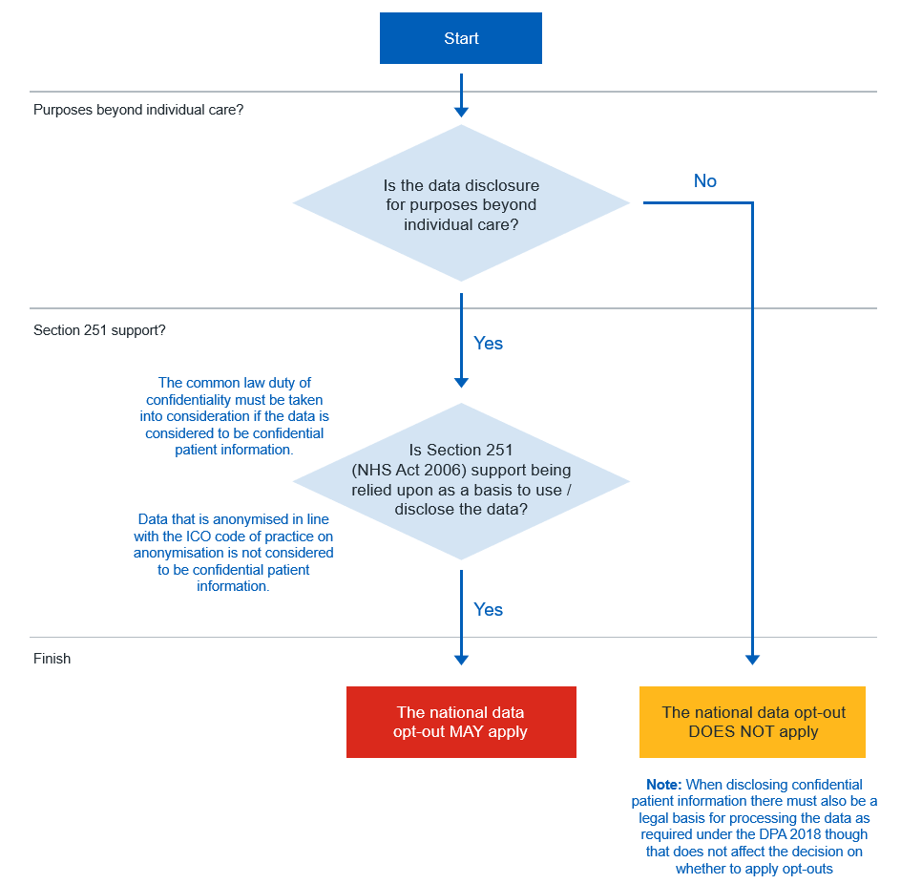

* The NDOO is overwritten if a patient gives explicit consent for research, in this case **if a practice writes to the patient inviting them to take part the patient can give consent**. Their information can then be provided to the research organisation for this specific study.  More information is available at: [Section 251 and the application of national data opt-outs](https://digital.nhs.uk/services/data-access-request-service-dars/how-the-national-data-opt-out-affects-data-released-by-nhs-digital/national-data-opt-out-guidance-for-researchers/4-section-251-and-the-application-of-national-data-opt-outs)
* Where researchers need to identify people to participate in research studies, the national data opt-out may apply to this process depending on the mechanism used to identify potential research subjects.
* In certain scenarios, researchers may need to access confidential patient information to identify people with particular conditions or characteristics to invite them to take part in clinical trials and other interventional studies. This process is often referred to as seeking “consent for consent”.  There are a number of established mechanisms for identifying potential research subjects which are set-out in the [2013 IG Review](https://www.gov.uk/government/uploads/system/uploads/attachment_data/file/192572/2900774_InfoGovernance_accv2.pdf) and the application of the national data opt-out to each of these is summarised below:

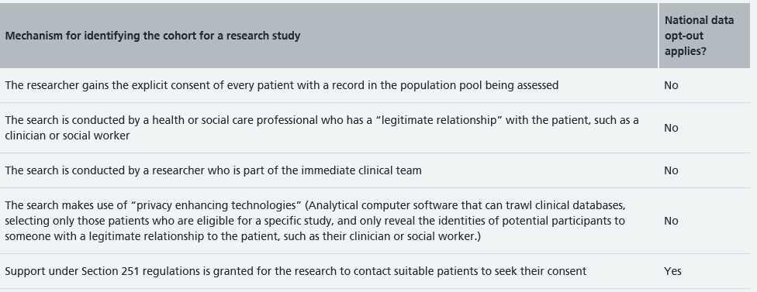

# Useful resources

[National data opt-out: compliance implementation guide - NHS Digital](https://digital.nhs.uk/services/national-data-opt-out/compliance-with-the-national-data-opt-out/compliance-implementation-guide)

[Information for GP practices - NHS Digital](https://digital.nhs.uk/services/national-data-opt-out/information-for-gp-practices)

# Document Control

**This document was created by NHS South Central and West Commissioning Support Unit (SCW) and as such the IP rights of this document belong to SCW.**

|  |  |  |  |  |
| --- | --- | --- | --- | --- |
| **Document Name** | **Version** | **Status** | **Author** | |
| *National Data Opt Out Guidance for Primary Care* | 1.3 | Published | NHS SCW Information Governance Services | |
| **Document objectives:** | This document supports Practice staff in compliance with Data Protection legislation, achieving best practice in the area of Information Governance and in meeting the requirements of the Data Security and Protection Toolkit | | | |
| **Target audience:** | All staff | | | |
| **Monitoring arrangements and indicators:** | This document will be monitored by NHS SCW Information Governance Services to ensure any legislative changes that occur before the review date are incorporated. | | | |
| **Review frequency** | SCW reviews customer documents in line with our planned schedule | | | |
| **SCW Planned Review date** | 01 January 2025 | | | |
| **Date uploaded to SCW Website** | 10 May 2023 | | | |
| **Approved & ratified by practice** | [Insert name of Group] | | | Date: [XX-XX-XXXX] |
| **Date issued by practice** | [XX-XX-XXXX] | | | |
| **GP Review date:** | [XX-XX-XXXX] | | | |

**Change record**

|  |  |  |  |  |
| --- | --- | --- | --- | --- |
| **Date** | **Author** | **Version** | **Page** | **Reason for Change** |
| 27.08.2020 | SCW | 1 | All | Review for Website publication |
| 29.10.2021 | SCW | 1.1 | All | Updated to reflect changes in NDOO and Type 1 Opt Out programme. |
| 31/3/2022 | SCW | 1.2 | All | Updated to reflect changes in NDOO compliance |
| 19/01/2023 | SCW | 1.3 | All | Reviewed and updated to reflect that the compliance date has now passed |